Batch: A-3 Roll No.: 16010122104
Experiment No. 4
Grade: AA / AB / BB / BC / CC / CD /DD

Title: Hosting Your Website On Google App Engine.

Objective:

The objective of hosting a website on Google App Engine (GAE) is to deploy and manage applications in a serverless, scalable, and highly available environment without worrying about infrastructure. GAE automatically handles scaling, load balancing, and maintenance, allowing developers to focus on building applications. It integrates seamlessly with Google Cloud services and offers a cost-efficient pay-as-you-go model, making it ideal for dynamic web applications.

Expected Outcome of Experiment:

CO | Outcome
 | Hosting Website on Google App Engine

Books/ Journals/ Websites referred:

https://gaesamplesite.appspot.com/downloads.html
https://shell.cloud.google.com/?pli=1&show=ide%2Cterminal

Abstract:-
Hosting a website on Google App Engine (GAE) enables developers to deploy web applications in a fully managed, serverless environment with automatic scaling and high availability. By eliminating the need for infrastructure management, GAE allows for seamless integration with Google Cloud services, ensuring efficient performance, cost-effectiveness, and ease of deployment. This makes it an ideal solution for developers looking to build and scale applications effortlessly.
Related Theory: -
Hosting a website on Google App Engine (GAE) is based on the principles of cloud computing, Platform-as-a-Service (PaaS), and serverless architecture.
- Cloud Computing – GAE leverages cloud infrastructure to provide on-demand resources, ensuring scalability, reliability, and cost efficiency.
- Platform-as-a-Service (PaaS) – GAE abstracts infrastructure management, allowing developers to focus on writing code while Google handles deployment, scaling, and security.
- Serverless Architecture – GAE automatically provisions and manages resources, scaling applications based on demand without requiring manual server management.
- Auto-Scaling and Load Balancing – GAE dynamically adjusts computing resources, distributing traffic efficiently to handle varying workloads.
- Microservices and Containerization – GAE supports microservices architecture and containerized applications, enabling modular and scalable development.
- Integration with Google Cloud Services – GAE seamlessly connects with services like Cloud Storage, Firestore, BigQuery, and Cloud Functions, enhancing application capabilities.
By utilizing these concepts, Google App Engine simplifies web hosting, ensuring high availability, efficiency, and ease of deployment for developers.

Implementation Details:
1. Enlist all the Steps followed and various options explored
2. Explain your program logic, classes and methods used.
3. Explain the Importance of the approach followed by you

- Steps
Step1: Go to the App Engine dashboard on the Google Cloud Platform Console and press the Create button.
Step 2: If you've not created a project before, you'll need to select whether you want to receive email updates or not, agree to the Terms of Service, and then you should be able to continue.
Step 3: Enter a name for the project, edit your project ID and note it down. Project Name: MyCloudProject Project ID: 133319421626
Step 4: Click the Create button to create your project.
Creating an application
Step 1: We'll need a sample application to publish. If you've not got one to use, download and unzip this sample app (http://gaesamplesite.appspot.com/downloads.html) For trial you use this. But for practical Execution you have to create your own application
Step 2: It includes the website folder contains your website content and app.yaml is your application configuration file. Your website content must go inside the website folder, and its landing page must be called index.html, but apart from that it can take whatever form you like. The app.yaml file is a configuration file that tells App Engine how to map URLs to your static files. You don't need to edit it. Publishing your Application Section Now that we've got our project made and sample app files collected together, let's publish our app.
Step 1: Open Google Cloud Shell (https://console.cloud.google.com/cloudshell/editor) Step 2: Drag and drop the sample-app folder into the left pane of the code editor. Step 3: Run the following in the command line to select your project: gcloud config set project gaesamplesite
Step 4: Run the following command to go to your app's directory: cd sample-app
Step 5. Upload your app to App Engine: gcloud app deploy
• Enter a number to choose the region where you want your application located.
• Enter Y to confirm. Now navigate your browser to your-project-id.appspot.com to see your website online. Reference https://developer.mozilla.org/enUS/docs/Learn/Common_questions/How_do_you_host_your_website_on_Goo gle_App_Engine

OUTPUT:

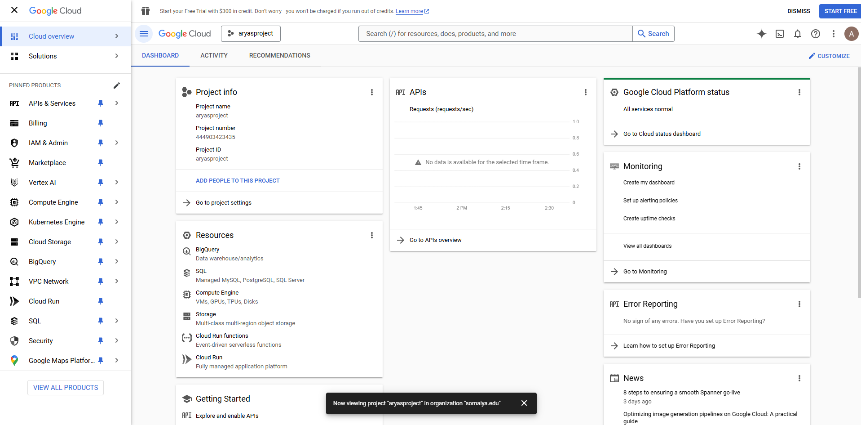
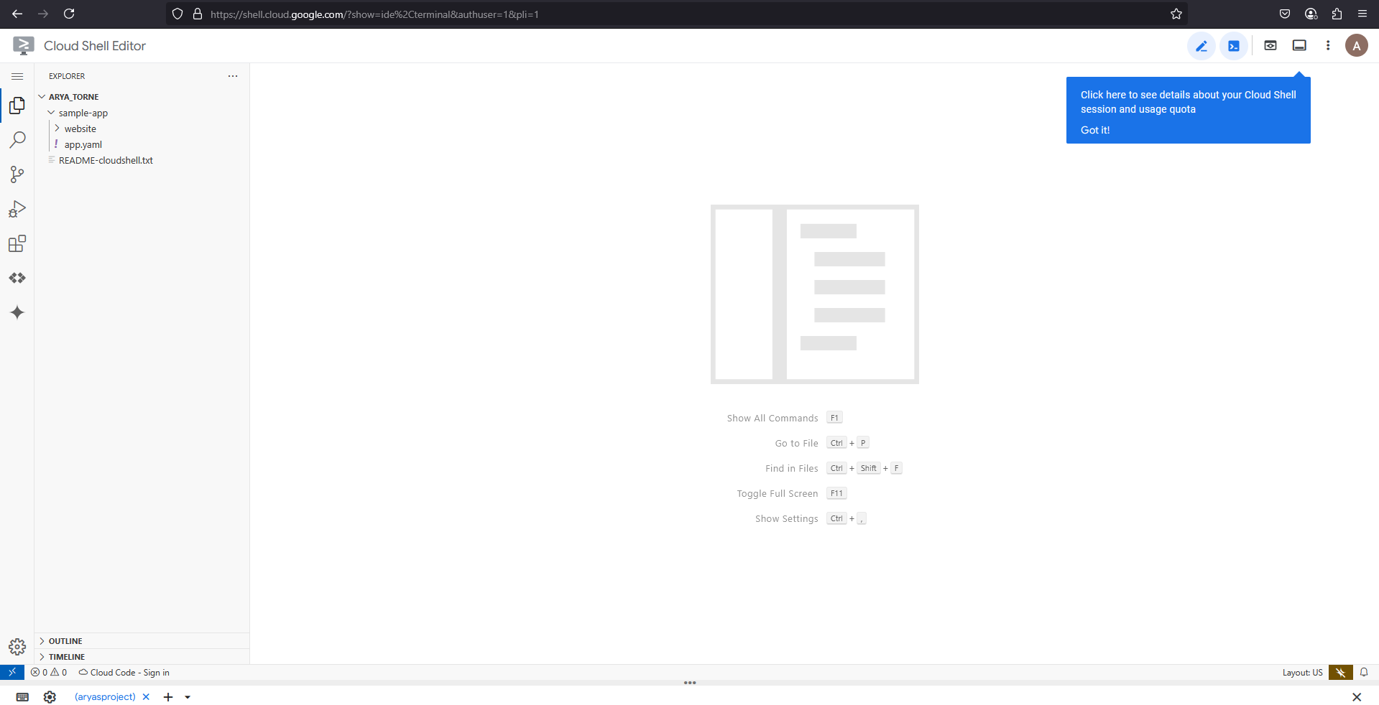
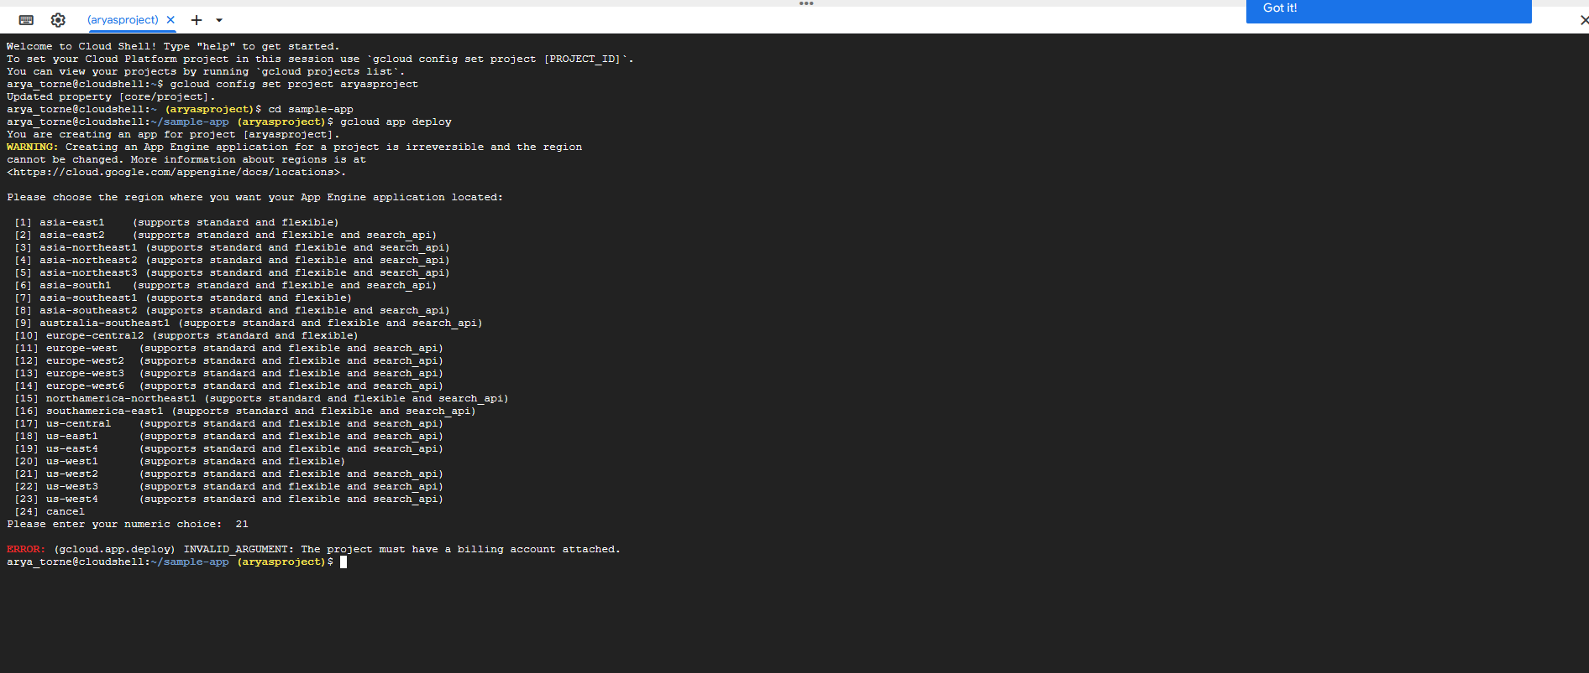

Conclusion:-
Hosting a website on Google App Engine (GAE) leverages cloud computing, PaaS, and serverless architecture to provide a scalable, efficient, and hassle-free deployment environment. With automatic scaling, load balancing, and seamless integration with Google Cloud services, GAE ensures high availability and cost-effectiveness, making it an ideal solution for modern web applications.

